# **Human Following Robot**

**Achivements**

**Description**

**Block Diagram / Circuit Diagram**

**Bluetooth-controlled** cars using Arduino are popular among hobbyists and students because they are easy to build and can be controlled using a smartphone. [These cars are also a great way to learn about programming, electronics, and robotics](https://circuitbest.com/how-to-make-bluetooth-controlled-car-using-arduino/).

The Bluetooth-controlled car project is an excellent example of how to use the Arduino board to control a robot car wirelessly. The HC-05 Bluetooth module is used to receive signals from the smartphone, and the L298N motor driver is used to control the DC motors that drive the car’s wheels. [The Arduino board acts as the brain of the car, processing the signals from the Bluetooth module and sending commands to the motor driver](https://circuitbest.com/how-to-make-bluetooth-controlled-car-using-arduino/).

The project is Bluetooth-based because it provides a wider range of control and more efficiency. It also allows the user to change the remote anytime, meaning that any Android device, including phones, tablets, and computers, can be used to control the car. [Physical barriers like walls and doors do not affect controlling the car.](https://ijettjournal.org/assets/year/2016/volume-33/number-8/IJETT-V33P274.pdf)

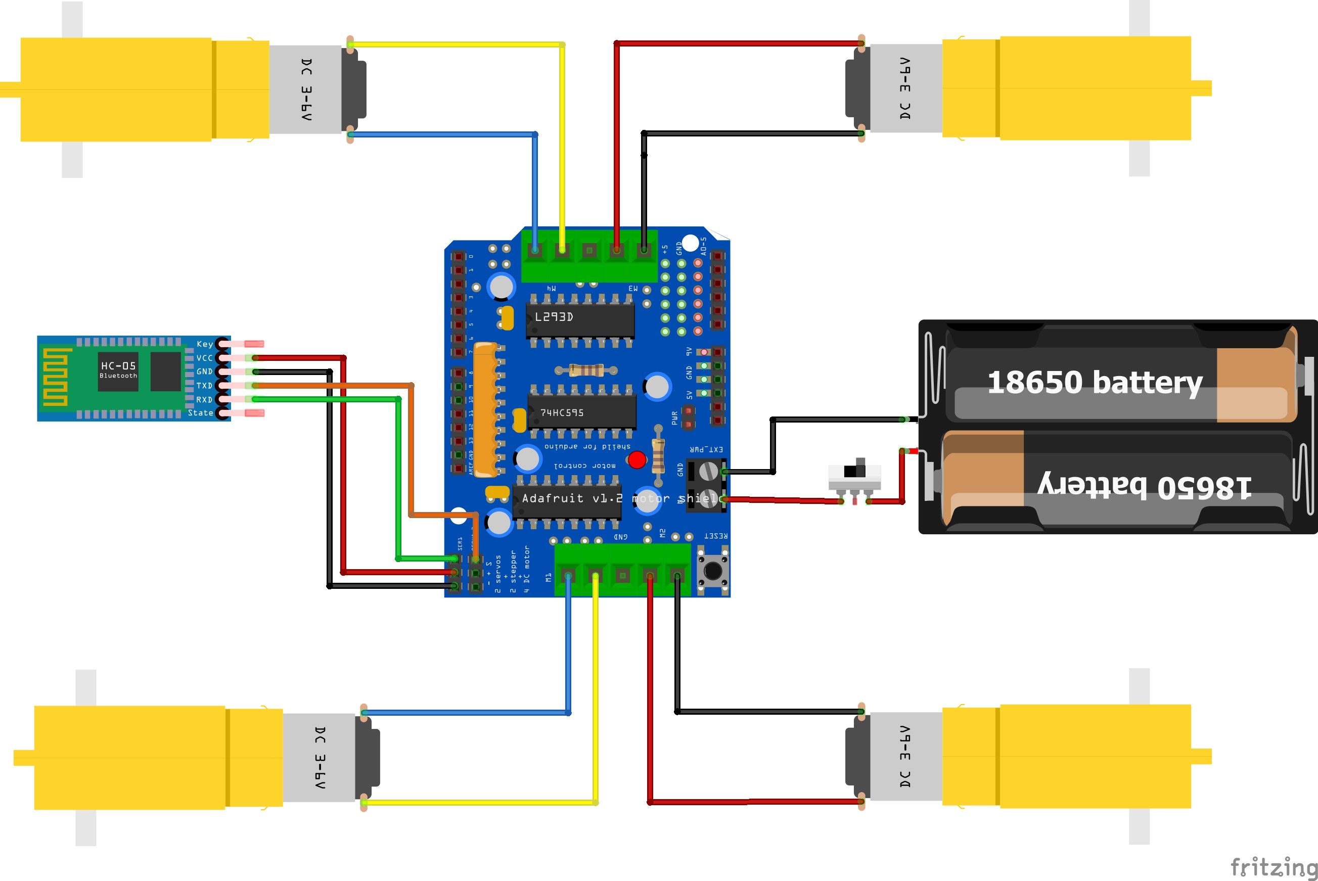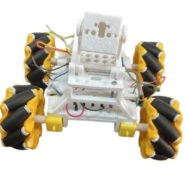

|  |  |  |
| --- | --- | --- |
| **Sr. No.** | **Name of Group Members** | **Roll. No.** |
|  | **Sharad Humbe (T.Y Electrical Engineering)** | **EL3149** |
|  | **Ajinkya Shinde (T.Y Electrical Engineering)** | **EL3154** |
|  | **Gaurav Maske (T.Y Electrical Engineering)** | **EL3106** |
|  | **Anil Mundhe (T.Y Electrical Engineering)** | **EL3107** |

Participate in TECHNOTSAV_2023 (JSPM’S RSCOE PUNE).

Participate in INNOVISION_RSCOE_2023.